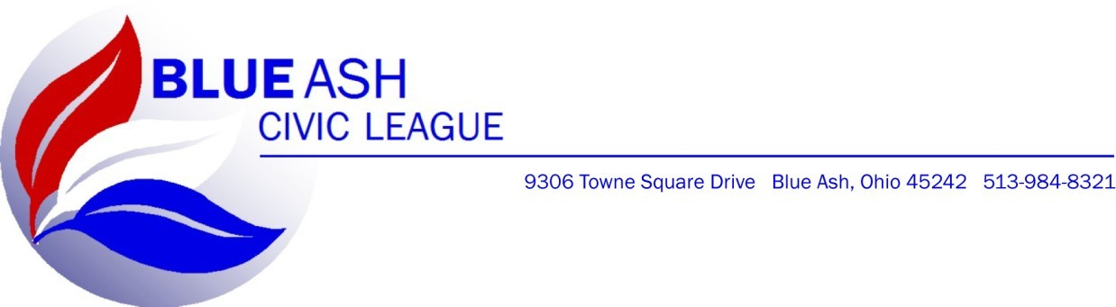
Blue Ash Civic League Hall Rental Agreement

The Blue Ash Civic League, which includes the Hall Manager, Officers and Trustees of The Blue Ash Civic League (hereinafter “BACL”) & _________________________ (hereinafter “Patron”), enter into this Hall Rental Agreement (hereinafter “the Agreement”) on the Terms and Conditions set out below:

*THIS IS A LEGALLY BINDING CONTRACT*

- THE EVENT:
Type of Event: ____________________________________
Date of Event: ____________________________________
Time of Event: ____________________________________
Duration of Event (Hours): __________________________________
Rental Fee: ____________________________________
Security Deposit: ____________________________________
Set-Up/Tear-Down Charge: ____________________________________ Clean-Up Charge ____________________________________

- FACILITY—BACL agrees to permit Patron to use its Facility, located at 9306 Towne Square Avenue, Blue Ash, Ohio 45242, (hereinafter “the Facility”) for the above described event. Patron may only use the Facility for the purpose of the above described event and shall not use the Facility in any other manner unless agreed to by BACL in writing. Patron agrees to keep the Facility in a clean and orderly condition and shall conduct its business in a reasonable, careful, and safe manner. Patron agrees not to use the Facility in any manner constituting a violation of any ordinance, law, statue, regulation, or zoning ordinance. Patron shall maintain the Facility in a reasonable manner during the event and agrees to return the Facility in substantially similar condition after the event. BACL and Patron may agree on an additional post event Clean-Up Charge as described above.
- PARTIES TO THE AGREEMENT—This Agreement is between BACL and Patron only. Patron warrants that it is the true party responsible for the Event and shall not assign or transfer this Agreement in whole or part, sublet the Facility or any part thereof, nor grant a license or concession in connection therewith without the prior written consent of the BACL. Such consent shall not be unreasonably withheld.
- DECORATIONS—Patron shall not cause or permit any alterations, additions, or changes to any part of the Facility without first obtaining the written consent of the BACL. All alterations, additions or changes to the Facility shall be made in accordance with all applicable laws. Patron may reasonably decorate and arrange the facility in accord with the Event, provided the decorations and arrangements do not damage the Facility.
  - Throwing/dispersal of glitter, confetti or rice are strictly forbidden. Patron will hold the BACL, harmless from any injury occurring due to such use by persons other than the BACL or BACL’s agents, servants and/or employees.
  - The Patron CANNOT use any type of nails, glue, gum, tape, tacks, or anything on the walls of the facility. BACL may charge up to $10.00 per individual infraction of this provision.
  - The BACL will in good faith provide all items agreed upon, but reserves the right to make substitution with a similar item at the sole discretion of BACL.
- SECURITY DEPOSIT—A security deposit of $200.00, unless otherwise stipulated above, is required at the contract signing. Unless this agreement is otherwise breached, including, but not limited to, damages to the Facility or failure of either party to fulfill their duties under this agreement, this deposit shall be returned within Thirty (30) Days after the Event. In the event any or all of the Security Deposit is withheld, BACL will provide a written explanation for the withholding.
  - The BACL reserves the right to inspect and control all parties and meetings held at the Facility. The Patron will be responsible for any damages to the building, equipment, decoration or fixtures, lost or damaged during the event. BACL HAS THE RIGHT TO CHARGE ACCORDINGLY TO ANY SIGNIFICANT DAMAGES TO THE FACILITY, INCLUDING DAMAGES THAT EXCEED THE SECURITY DEPOSIT.
  - The Leased Facility is a Non-Smoking facility. Patron shall make sure none of their guests smoke inside the facility. Forfeit of the entire SECURITY DEPOSIT Can/Will be the penalty.
- PAYMENT TERMS—Upon payment of the Security Deposit and execution of this Agreement, BACL will reserve the Facility for Patron for the Date and Time of the Event as described above.
  - The Rental Fee must be paid by Cash or Check one month before the date of the event, unless other written arrangements are made prior to the signing of this agreement. Alternative billing arrangements must be approved in writing by BACL in advance.
  - Patron shall pay all applicable Federal, State, and Municipal taxes and fees.
  - In the event Patron cancels or otherwise breaches this contract; the BACL shall retain all payments made by the Patron as liquidated damages arising from its compliance with this Agreement.
  - Upon receiving written notice canceling an Event, BACL shall make every reasonable effort to re-book a canceled Event Date. If BACL is able to book another Event on a canceled date, BACL will refund Fifty Percent (50%) of the Rental Fee. The remaining amount shall be a rebooking fee.
  - The Date and Time of the Event may be changed at NO ADDITIONAL CHARGE as long as the new date is available, and a written request is received by BACL at least Seven (7) Days prior to the scheduled event.
  - If BACL, in its sole discretion, determines that Patron breached this Agreement for good cause, BACL may, but is not required to, refund any or all payments made under this agreement.
  - Such retention of initial payments shall not relieve the Patron of any additional liability to the BACL under this Agreement.
- RESPONSIBILITY FOR PERMIT/LICENSE—Whenever a license and/or permit is required for Patron’s function, such license and/or permit shall be procured from the proper public authorities by the Patron at Patron’s own cost and expense.
- HOLD HARMLESS AND INDEMNITY PROVISION—Regardless of whether or not, separate,
several, joint or concurrent liability may be imposed upon BACL, Patron shall indemnify and hold BACL harmless for any and all damages, claims and liability arising from or connected to Patron’s control or use of the Facility, including without limitation, any damage or injury to person(s) or property.
  - If BACL becomes party to litigation commenced by or against Patron, then Patron shall indemnify and hold BACL harmless. The indemnification provided by this Section includes BACL’s legal costs and fees in connection with any such claim, action, or proceeding.
  - Patron does hereby release BACL from all liability for any accident, damage or injury caused to person or property on or about the Facility, whether due to negligence on the part of BACL and notwithstanding whether such acts or omission be active or passive.
  - Patron agrees to indemnify and hold BACL harmless for any and all claims arising from service or consumption of any and all Food or Beverages brought into or taken outside of the Facility during or after an Event.
- RISK OF LOSS—The BACL will NOT be responsible for articles lost, stolen, or forgotten during the course of the event.
- COLLECTION & ATTORNEY’S FEES—Patron shall pay BACL’s reasonable legal costs and
attorney’s fees incurred in enforcing the provisions of this agreement. Patron agrees that in the event of default in payment, reasonable costs of collection, equal to fifty (50) percent of the delinquent balance, and/or reasonable attorney fees may be added to the amount due on the account.
- VENUE AND CHOICE OF LAW—Patron and BACL agree that this agreement shall be governed by the laws of the State of Ohio and that venue shall be proper in Hamilton County, Ohio, for any and all disputes arising from this Lease and the use of the Facility described herein.
- ENTIRE AGREEMENT—This agreement constitutes the entire contract between the Patron and the BACL. No oral modification thereof shall be valid or binding nor has any force or effect, except of this contract agreement, which the Patron makes to the BACL, can be oral and shall be binding.
- SEVERABILITY—This agreement is severable. The invalidity or unenforceability of any provisions of this Agreement shall not affect the validity or enforceability of any other provision of this Agreement, which shall remain in full force and effect.
- MULTIPLE COUNTERPARTS—This Agreement may be executed as multiple counter parts. IF this agreement is executed as multiple counterparts, each shall be deemed an original.

IN WITNESS WHEREOF, BACL and Patron(s) have executed this rental agreement as of this ______ Day of ___________________, 20___, and if this

Patron Organization: ________________________________
Authorized Patron Signature: ________________________________
Printed Name/By: ________________________________
Address: ____________________________
City, State, Zip: ________________________
Phone: _______________
Email: ___________________

BACL Authorized Signature: _____________________
Printed: __________________________

